Unit 3 Algorithmics
Submit Task – Week 5
Debugging
Find the errors in the pseudocode below by changing/adding one line of code.
Depth first search:
DFS(node):
mark node as visited
print node
for each neighbour in neighbours of node:
if neighbour is not visited:
mark neighbour as visited

Breadth first search:
BFS(graph, start):
create an empty queue Q
enqueue start into Q
mark start as visited

while True:
node = dequeue Q
print node
for each neighbour in neighbours of node:
if neighbour is not visited:
mark neighbour as visited
enqueue neighbour into Q

Rumour Spreading
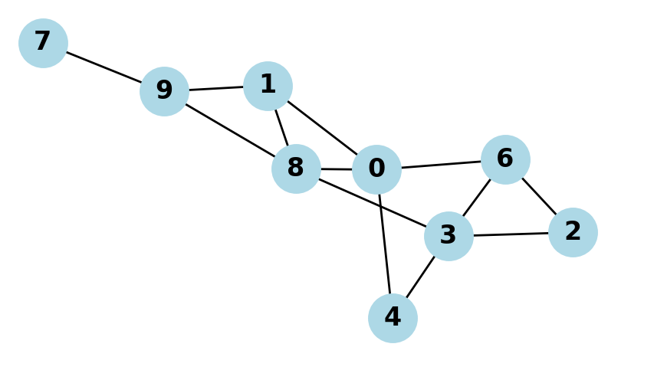
This graph models 10 people as nodes, with their friendship connections as edges. Person number 0 finds out a rumour on Day 0. On each subsequent day, everyone tells all of their friends (unless they just found out that day).
- Assuming that nodes are added to the queue/stack in numerical order as a tie-breaker, write down the order in which BFS and DFS would each choose nodes, starting with #1.
- If a person spreads a rumour to all of their friends on a given day, describe how we would use one of these search patterns to find out how many days it would take for everyone on the graph to know about the rumour.

